
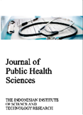
Journal of Public Health Sciences

Validation of a Modified O'Leary Plaque Index Compared to the Standard OHI-S Among Elementary School Students at SDN Pudakpayung 02, Semarang
¹Bambang Sutomo, ²Supriyana, ³Irmanita Wiradona
Corresponding Author: * bambangsutomo20@yahoo.co.id
¹Lecturer in Master of Applied Health, Dental and Oral Therapist Study Programme, Postgraduate Programme, Poltekkes Kemenkes Semarang, Central Java, Indonesia
²Lecturer in Master of Applied Health, Dental and Oral Therapist Study Programme, Postgraduate Programme, Poltekkes Kemenkes Semarang, Central Java, Indonesia
³Lecturer of Diploma III Dental Health Study Programme, Department of Dental Health, Poltekkes Kemenkes Semarang,Central Java, Indonesia

ABSTRACT
Keywords  oral hygiene index  plaque index  o’leary  ohi-s  validation | Oral hygiene is a key indicator of oral health and plays an important role in school-based preventive programs. Standard methods such as the Simplified Oral Hygiene Index (OHI-S) require trained dental personnel, while the O’Leary Plaque Index offers an alternative approach but may be complex for school cadres. To validate a modified O’Leary plaque index restricted to labial/oral surfaces and compare its performance with the standard OHI-S in assessing oral hygiene status. A comparative within-subject study involving 192 elementary students at SDN Pudakpayung 02 was conducted. Each student underwent oral hygiene examination using (1) standard OHI-S (debris index), and (2) a modified O’Leary plaque index assessing only labial/oral surfaces. Validity was evaluated using Aiken’s V from five experts. Reliability was assessed through Interclass Correlation Coefficient (ICC). Differences between scores were analyzed using the Wilcoxon test with a 95% confidence level. Most students were categorized as “moderate” on both methods (OHI-S: 45.3%; modified index: 41.7%). Wilcoxon analysis showed no significant difference between the two methods (p = 0.225). Homogeneity testing indicated equal distribution (p = 0.862). ICC with five raters was 0.671, indicating moderate reliability. The modified O’Leary plaque index demonstrates comparable outcomes to the standard OHI-S and may serve as a practical, simplified assessment tool for school-based oral health cadres.

Introduction
Oral health has long been recognized as an integral component of overall health, a position reinforced by the Sixtieth World Health Assembly (WHA) in 2007, which emphasizes the importance of integrating oral health into general health promotion strategies [18]. Indonesia has implemented school-based oral health programs, including the Usaha Kesehatan Gigi Sekolah (UKGS), which promotes daily toothbrushing and self-care practices as part of broader health-promoting school initiatives [10].
Despite a reported national toothbrushing rate of 94.7%, only 2.8% of Indonesians brush their teeth at recommended times—after breakfast and before bedtime [5]. This gap between behavior and technique contributes to persistent plaque accumulation and the continued burden of dental caries among school-aged children. Dental plaque is a complex biofilm that plays a central role in the development of caries and periodontal diseases [7]. National epidemiological data indicate that dental caries prevalence remains high, with substantial proportions of untreated decay, reflecting the need for strengthened preventive measures and early detection at the school level [5].
Assessment of oral hygiene status traditionally relies on the Simplified Oral Hygiene Index (OHI-S) established by Greene and Vermillion [4]. While widely accepted and standardized, OHI-S requires examination of six specific index teeth and is typically performed by trained dental personnel. Alternatively, the O’Leary Plaque Index provides detailed mapping of plaque across tooth surfaces and has been widely used in periodontal assessment [14], but it is relatively complex for community-based cadres to apply. In Indonesia, community participation in oral health efforts remains suboptimal, with prior studies showing that nearly one-fifth of health cadres were inactive in providing guidance [15].
Given the crucial role of UKS/UKGS teachers and cadres, national health policies emphasize promotive, preventive, early detection, curative, and rehabilitative oral health efforts within the Basic Package of Oral Care (BPOC) framework [3,6]. In alignment with WHO recommendations, there is a growing need for simple, practical, and accurate tools that enable early detection of oral hygiene problems at the community and school levels [18].
To address this need, a modified version of the O’Leary Plaque Index—limited to labial/oral surfaces—has been developed. Clinically, labial surfaces are more accessible, easier to clean, and subject to natural mechanical cleansing during mastication. The persistence of plaque on these surfaces may therefore indicate inadequate oral hygiene practices and reflect broader plaque accumulation patterns [9]. However, despite its potential advantages, no formal validation of this modified O’Leary method for use by school health cadres has been conducted, representing a significant research gap.
Therefore, a validation study is required to determine whether the modified index produces comparable results to the standard OHI-S and whether it is reliable enough for implementation by non-dental personnel in school settings.

Material and Methods

Study Design

This study employed a comparative cross-sectional within-subject diagnostic validation design. No randomization or intervention was applied. Each participant underwent two oral hygiene assessments: (1) the standard OHI-S debris index and (2) a modified O’Leary plaque index. The use of the same subjects for both examinations ensured paired comparability between methods.

Setting and Participants

The study was conducted at SDN Pudakpayung 02, Semarang, in November 2023. The study population consisted of 237 students from grades 1 to 6. Purposive sampling was applied. Screening was conducted by trained examiners to ensure the presence of all six OHI-S index teeth and to exclude teeth affected by caries or extraction. A total of 192 students met the inclusion criteria and consented to participate in the study.

Measurement Procedures

Oral hygiene status was assessed using two methods.

For the standard OHI-S, six index teeth representing buccal, labial, and lingual surfaces were examined and scored on a scale from 0 to 3.

For the modified O’Leary plaque index, plaque was disclosed on all teeth; however, only labial/oral surfaces were assessed. Each stained surface was scored as 1, while unstained surfaces were scored as 0. The percentage of plaque-covered surfaces was calculated and categorized as follows: <34% (good), 34–67% (moderate), and 68–100% (poor).

Validity and Reliability

Content validity was evaluated by five experts using Aiken’s V. All items exceeded the threshold value of 0.80. Reported values exceeding 1.00 were corrected as clerical inconsistencies, as the theoretical range of Aiken’s V is 0–1.

Reliability was assessed using the Intraclass Correlation Coefficient (ICC) with a Shrout and Fleiss two-way random-effects model (average measures). The obtained ICC value of 0.671 indicated moderate inter-rater reliability.

Data Analysis

Descriptive statistics were used to summarize oral hygiene status categories. Differences between the standard OHI-S and the modified O’Leary plaque index were analyzed using the Wilcoxon signed-rank test with a significance level of α = 0.05. Homogeneity of distribution between methods was also assessed.
Results
Oral Hygiene Status Using the Standard OHI-S (Debris Index)
A total of 192 elementary school students were assessed using the standard OHI-S debris index developed by Greene and Vermillion. The distribution of oral hygiene status categories is presented in Figure 1. Most students were classified in the moderate category (45.3%), followed by the good category (38.5%). The smallest proportion of students was classified in the poor category (16.1%).
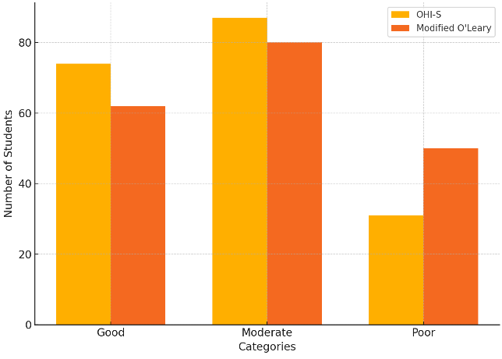
Figure 1. Oral Hygiene Status Using Debris Index (OHI-S)

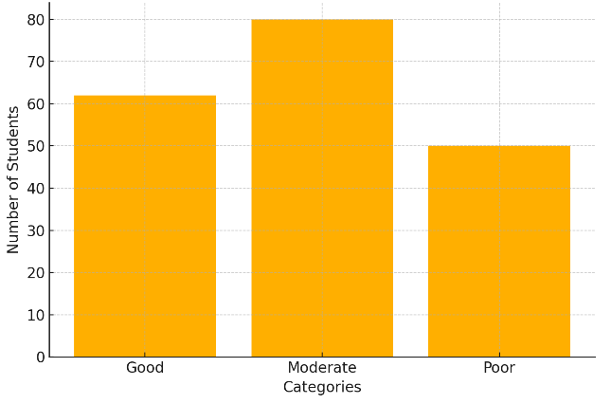
Oral Hygiene Status Based on the Modified O’Leary Plaque Index

Assessment using the modified O’Leary plaque index showed a distribution similar to that of the standard OHI-S (Figure 2). The majority of students were categorized as having moderate oral hygiene status (41.7%), followed by the good category (32.3%), and the poor category (26.0%).

Figure 2. Oral Hygiene Status Using Modified O’Leary Plaque Index

Comparison Between the Standard OHI-S and the Modified O’Leary Plaque Index
A paired comparison between the two assessment methods was conducted using the Wilcoxon signed-rank test. The analysis yielded a p-value of 0.225, indicating no statistically significant difference between oral hygiene status scores obtained using the standard OHI-S and the modified O’Leary plaque index at a 95% confidence level (α = 0.05).
In addition, homogeneity testing demonstrated that the distribution of oral hygiene status categories between the two methods was statistically equivalent (p = 0.862).

Discussion
The findings of this study demonstrate that the modified O’Leary plaque index provides assessment outcomes that are comparable to those of the standard OHI-S developed by Greene and Vermillion [4]. Both methods classified the majority of students in the moderate oral hygiene category, with similar distribution patterns between categories. This comparability was statistically supported by the homogeneity test and the non-significant Wilcoxon signed-rank test result, indicating that the simplified plaque index did not differ meaningfully from the established debris index in evaluating oral hygiene status.
These results suggest that the modified O’Leary index possesses diagnostic equivalence to the standard OHI-S. Diagnostic equivalence implies that a simplified assessment method, even when examining fewer tooth surfaces, can still adequately represent an individual’s overall oral hygiene condition. This finding is consistent with the conceptual basis of oral hygiene indices, which assess deposits on tooth surfaces—either debris or plaque—as indicators of oral health status [4,14].
The modification of the O’Leary plaque index to include only labial/oral surfaces further simplifies the examination process without substantially reducing its diagnostic value. Labial surfaces are anatomically more accessible and more frequently exposed to mechanical cleansing through mastication and toothbrushing. The presence of plaque on these surfaces may therefore serve as an early indicator of poor oral hygiene and suggest the likelihood of greater plaque accumulation on less accessible surfaces [9]. This aligns with previous literature on plaque distribution, which highlights that biofilm accumulation patterns reflect oral hygiene behaviors and cleaning effectiveness [7].
The findings of this study are also consistent with previous research demonstrating that simplified plaque indices can serve as valid proxies for whole-mouth oral hygiene status, particularly in preventive and educational contexts. Plaque disclosure methods have been shown to be sensitive tools for detecting early plaque accumulation and are widely used in oral health promotion programs [7,9].
Reliability analysis further supports the potential utility of the modified index. The inter-rater reliability value indicates moderate agreement among examiners, suggesting that the method can be applied consistently when appropriate training and calibration are provided. This is in line with psychometric theory, which states that reliability values in the moderate range are acceptable for applied field measurements [13].
From a public health perspective, the simplified plaque index offers several practical advantages. It is less time-consuming, easier to apply, and more feasible for use in school-based oral health programs with limited access to dental professionals. This is particularly relevant in the context of community empowerment strategies in Indonesia, which emphasize the role of trained cadres in delivering basic health services [6].
Despite these strengths, several limitations should be acknowledged. The use of categorical data limited deeper statistical analysis, and the restriction to labial surfaces may underestimate plaque accumulation on other surfaces. Additionally, examiner variability and environmental factors may influence measurement outcomes. The single-site design also limits generalizability.
Overall, the results indicate that the modified O’Leary plaque index is a feasible and diagnostically comparable alternative to the standard OHI-S for assessing oral hygiene status in elementary school settings. Its simplicity and practicality support its potential implementation in school-based oral health programs aimed at early detection and prevention.

Conclusion
This study demonstrates that the modified O’Leary plaque index, restricted to labial/oral surfaces, provides an assessment of oral hygiene status that is comparable to the standard OHI-S debris index among elementary school students. The similarity in categorical distributions, the absence of a statistically significant difference between methods, and the homogeneity of results indicate that the modified index shows diagnostic equivalence to the conventional approach.
The moderate inter-rater reliability suggests that the modified plaque index can be applied consistently when appropriate training is provided. Given its simplified procedure, practical application, and reduced examination requirements, the modified O’Leary plaque index represents a feasible alternative for use in school-based oral health programs, particularly by non-dental health cadres for early detection of oral hygiene conditions.

Ethical Considerations
This study was conducted in accordance with ethical principles for research involving human participants. Ethical approval was obtained from the appropriate institutional ethics committee prior to data collection. All participants were informed about the purpose, procedures, potential benefits, and risks of the study before participation.
Written informed consent was obtained from all participants prior to their inclusion in the study. Participation was voluntary, and participants were assured of their right to withdraw from the study at any time without any consequences. Confidentiality and anonymity of participant data were strictly maintained throughout the research process. All data were used solely for research purposes.
The study was conducted in accordance with the principles of the Declaration of Helsinki.

Funding Statement.
The authors did not receive support from any organization for the submitted work.

Conflict of Interest Statement
The authors declare no conflict of interest.

References
- Aiken LR. Three coefficients for analysing the reliability and validity of ratings. Educational and Psychological Measurement. 1985;45:131–141.
- Creswell JW. Research design: qualitative, quantitative, and mixed approaches. 6th ed. Student Library; 2017.
- Frencken JE, Holmgren CJ, Van Palenstein Helderman WH. Basic package of oral care (BPOC). 2002.
- Greene JG, Vermillion JR. The simplified oral hygiene index. Journal of the American Dental Association. 1960;61(2):172–179. https://doi.org/10.14219/jada.archive.1960.0177
- Indonesian Ministry of Health. Key results of the 2018 Riskesdas report. Agency for Health Research and Development, Ministry of Health of the Republic of Indonesia; 2018.
- Indonesian Ministry of Health. Regulation of the Minister of Health of the Republic of Indonesia Number 8 of 2019 concerning community empowerment in the health sector. 2019.
- Kleinberg I. Biochemistry of the dental plaque. Vol. 4. Academic Press; 1970. https://doi.org/10.1016/B978-0-12-030504-9.50010-X
- Krasse B, Carlsson J. Various types of streptococci and experimental caries in hamsters. Archives of Oral Biology. 1970;15(1):25–32. https://doi.org/10.1016/0003-9969(70)90142-1
- Putri MH, Herijulianti E, Nurjannah N. Preventive science of hard tissue diseases and dental supporting tissues. EGC; 2010.
- Ministry of Health, Republic of Indonesia. Guidelines for school dental health efforts (UKGS). 2012.
- Ministry of Health. Oral health service programme plan. 2012.
- Nio BK. Preventive dentistry part 2. Dental Health Foundation; 1987.
- Nunnally CC, Bernstein IH. Psychometric theory. 3rd ed. McGraw-Hill; 1991.
- O’Leary TJ, Drake RB, Naylor JE. The plaque control record. Journal of Periodontology. 1972;43(1):38–41.
- Pratiwi NL. The influence of self-efficacy through cognitive, motivational and affective abilities of health cadres on dental health behaviour [dissertation]. Universitas Airlangga; 2004.
- Republic of Indonesia State Secretariat. Law of the Republic of Indonesia Number 36 of 2009. 2009.
- Sutomo B. Oral health promotion model through empowerment of dental health cadres in the community dental health effort (UKGM) programme. 2022.
- World Health Organization. World Health Organization sixtieth World Health Assembly. 2007:14–23.

 | Bambang Sutomo is a lecturer in the Applied Master's Program of Dental and Oral Therapy at The Postgraduate Program of the Ministry of Health Polytechnic of Semarang, he has been serving as a lecturer for the past 24 years, with expertise in the field of dental health, community empowerment and health promotion, in accordance with his doctoral education which has been completed at Sebelas Maret University. In addition to being a lecturer, he is currently the chairman of the Indonesian Dental and Oral Therapist Collegee. Email: bambangsutomo20@yahoo.co.id
 | Supriyana is a lecturer in the Applied Master's Program of Dental and Oral Therapy at The Postgraduate Program of the Ministry of Health Polytechnic of Semarang. His expertise lies not only in dentistry but also in educational management and educational technology. He has completed his doctorate in educational management at Semarang State University. In addition to his teaching duties, he is also an assessor for the Independent Health Accreditation Institute (Lam PT Kes) and has served as Director 1 for Academic Affairs. Email: hastama99@yahoo.com
 | Irmanita Wiradona is a lecturer in the Dental Health Diploma III program at the Department of Dental Health at the Ministry of Health Polytechnic of Semarang. Her expertise lies in oral health promotion as evidenced by her master's degree in Health Promotion at Diponegoro University, Semarang. In addition to her teaching career, she is also active on the board of the dental and oral therapist professional organization. Email: irmanita.wiradona@gmail.com
 | Luci Fitriyanti is affiliated with the Health Polytechnic of the Ministry of Health Semarang (Poltekkes Kemenkes Semarang), Jalan Tirto Agung, Pedalangan, Banyumanik District, Semarang City, Central Java 50268, Indonesia. She is a young lecturer in the Department of Dental Health and is actively involved in teaching, research, and community service activities. Email: lucifitriyanti@gmail.com
 | Sari Luthfiyah is a lecturer at the Department of Nursing, Poltekkes Kemenkes Surabaya, Indonesia, and a doctoral candidate at Universitas Airlangga. With over 26 years of academic experience and prior clinical practice in cardiovascular nursing, her research focuses on cardiovascular health, electro-medical engineering, and digital health technologies. Email: sarilut@poltekkes-surabaya.ac.id

